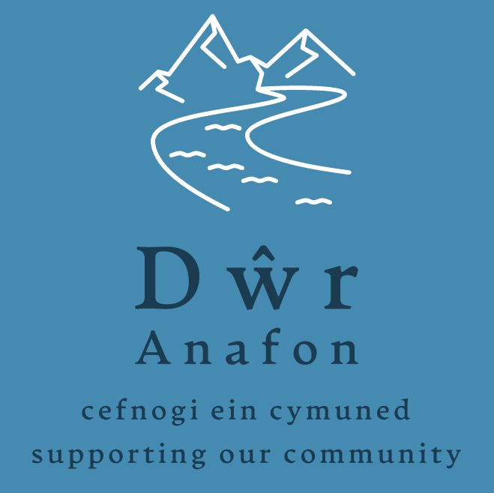

Energy Savings Project Application Form

Dwr Anafon wishes to support Energy Efficiency Measures (EEM) in the form of grants to homes (NB: this cannot be a retrospective grant where work has already started or a deposit paid/contracts agreed).

To apply for a grant please fill in the following form.
Please write / type clearly in black or blue ink.
Please answer every question. Where the question is not appropriate to your project please write Not Applicable (N/A)
Please note that funding will not be available for work that has already been started or contracted before submission of the application form

For Office Use Only:
Reference number..................... Date of receipt.........................

Section 1: About You

Name

Address | Post Code:
Contact details | Home phone:  Mobile:  Other:  E-mail address:

Section 2: About your energy efficiency project

Please describe your proposed project – Please note, Dŵr Anafon are only able to support improvements that have been recommended in your survey report. You should enclose a copy of the survey report with your application.

Work you plan to do for which you request assistance from Dŵr Anafon:

__________________________________________________________________________________

Do you, or anyone else involved in making this application, have a connection to any Dwr
Anafon trustee (current trustees are all listed on our website) who will potentially be involved
in making a decision on the application?

Yes No

If you have answered “Yes” please describe the nature of this connection.
What is the planned project start date?  What is the planned project completion date? | / /  / /

Section 3: Minimum 2 quotes obtained
(Please attach copies of each quote to this application form)
Contractor | Work quoted |  |  | Total  £
1.
2.
3.
Have you considered applying for funding from elsewhere? |  | Yes No
If the answer is No, please provide reason.
Has work been started/completed, a contractor been engaged or any deposit paid? |  | Yes No
Please list any other funding bodies that have been contacted and the amount of money requested |  |  | £
 |  |  | £
 |  |  | £
 |  |  | £
What amount are you requesting from Dŵr Anafon?  NB. Applicants may only apply once in any 12 month period |  |  | £

Section 4: Project Check List

The following documents must be included as part of your application:

- Written quotes or estimates

- A copy of your survey report

I confirm that all the information on this form is true and correct.

Name:
Signature: | Date:

DATA PROTECTION
Dŵr Anafon will use the information you provide, including personal information, for the purposes of dealing with your grant application only. Data will be securely stored for 7 years from the date of receiving the application or the date the project is completed, whichever is later. It will then be destroyed securely.

For further help or advice, or to return your completed Application Form and supporting documents please contact:

Dŵr Anafon, Yr Hen Felin, Abergwyngregyn, Llanfairfechan, LL33 0LP

or

info@dwranafon.co.uk

