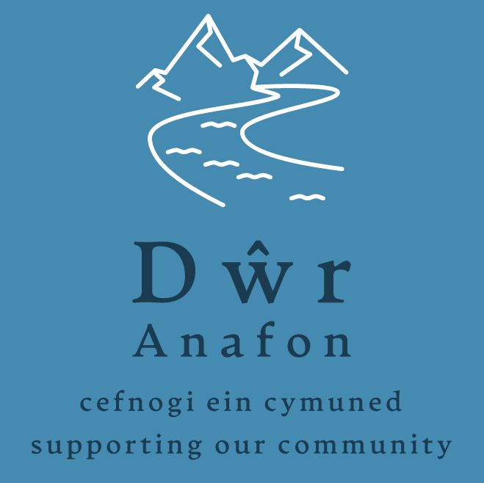

Application Form for Individuals

Make sure you have read the Guidelines for Applicants before you complete this application.
Please write / type clearly in black or blue ink.
Please answer every question. Where the question is not appropriate to your project please write Not Applicable (N/A)

For Office Use Only:
Reference number..................... Date of receipt.........................

Section 1: About You

Name

Address | Post Code:
Contact details | Home phone:  Mobile:  Other:  E-mail address:

Section 2: About your project

Please describe your proposed project – (What are you going to do?

__________________________________________________________________________________

Do you, or anyone else involved in making this application, have a connection to any Dwr
Anafon trustee (current trustees are all listed on our website) who will potentially be involved
in making a decision on the application?

Yes No

If you have answered “Yes” please describe the nature of this connection.
Which of the charities objectives will be fulfilled by this project – (State all that are applicable)
What benefits will your project bring to the community?
What evidence do you have that the project has the support of the community?

How will this funding help you to achieve your goal?
What is the planned project start date?  What is the planned project completion date? | / /  / /

Section 3: Project Financial Details

Expenditure |  | Cost  £ | VAT  £ |  | Total  £
Total Project Costs =

Have you applied for funding from elsewhere?  If the answer is No, please provide reason. | Yes No
Please list any other funding bodies that have been contacted and the amount of money requested |  |  |  | £
 |  |  |  | £
 |  |  |  | £
 |  |  |  | £
Grant aid sought from Dŵr Anafon  (Capped at £1,000)  Applicants may only apply once in any 12 month period |  | £

Section 4: Project Check List
The following documents should be included as part of your application, if applicable

- Written quotes or estimates

- Evidence/letters of community support for project

I confirm that all the information on this form is true and correct.

Name:
Signature: | Date:

DATA PROTECTION
Dŵr Anafon will use the information you provide, including personal information, for the purposes of dealing with your grant application only. Data will be securely stored for 7 years from the date of receiving the application or the date the project is completed, whichever is later. It will then be destroyed securely.

For further help or advice, or to return your completed Application Form and supporting documents please contact:

Dŵr Anafon, Yr Hen Felin, Abergwyngregyn, Llanfairfechan, LL33 0LP

or

info@dwranafon.co.uk

The following organisations can provide independent help and advice regarding grant application, including advice on match funding:

http://mantellgwynedd.com email: ymholiadau@mantellgwynedd.com

http://cvsc.org.uk email: mail@cvsc.org.uk

